
Sustainable care and management
ICT Task Week 3

Learning Intention:

Success Criteria:

Task 1

Investigate how the knowledge from Aboriginal and Torres Strait Islander Australians, surrounding care of waterways or sustainable management of the environment, is used to inform scientific decisions to care for Country of Place.
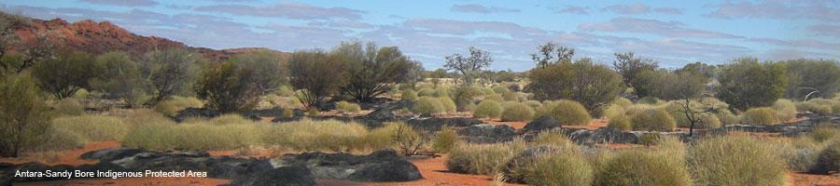

- Go to http://www.environment.gov.au/land/indigenous-protected-areas to start your research.
- Choose an area to investigate, either waterways OR land.
- Identify management practices of a particular area, for example National Landcare Facilitators.
- Include the following information in your presentations:
- An example where the management practices for caring for country is taking place
- The goal of the project
- The practices being employed to help achieve the goal
- How the management practices are helping to manage the environment
- An accurate bibliography to reference your information

Surname | Initial | Title of page | Full title of website | Date Written | Internet Address | Date of visit
Brown | J. | ‘Things in Space’ | Astronomy Facts | 1998 | http://www.astronomyfacts.com | 31 July 2019

- Present your findings using an ICT application e.g. PowerPoint.

